### Project Plan

1. **The purpose of the site**The purpose of this website is to give information about the movie detail screening time and to get visitors’ attention and encourage them to see the movie. In near future, the website would include online booking system for customer usability and the cinema could save the labor cost for ticketing staffs and could avoid the possibility of spreading covid-19.
2. **A brief description of the content the site will provide**The site will provide the information of movies, screening schedule and cinema location.
3. **The target audience**The target audience would be people who is over 18 because there is no animation movie or kids’ movie. The atmosphere of this cinema is “modern and classic” as if you are going to see Broadway show or any theatres.
4. **A brief discussion of the research conducted and the sites visited and what ideas you have gathered**I have researched website of theatres, such as civic theatre in Auckland, State theatre in Sydney, Apolo theatre and Shaftesbury theatres in UK. I found that most of website use black color as main color and “Book ticket button” on the right top of the website. On the top page, the images will be changed automatically and images are related to the theatre or show that they are playing now.
5. **The time plan showing time estimates (in hours) of each step of the website development including the details for planning, site build, and testing**I assume that…  
   Planning: 8~10 hours (1day)  
   Wireframe: 1~2hours  
   Site build: 2 days  
   Testing: 1 ~ 2 hours
6. **The wireframe sketches, to let you plan carefully what content you will provide and how you will lay them out on the page, before you build the page**I used Adobe XD to make wireframe because I would like to refer to font-size, color and basic design from competitors. If I make a wireframe on digital tool, I feel that it would be easy to start coding.  
   Below image is my wireframe for this website.

- screenshot of wireframe

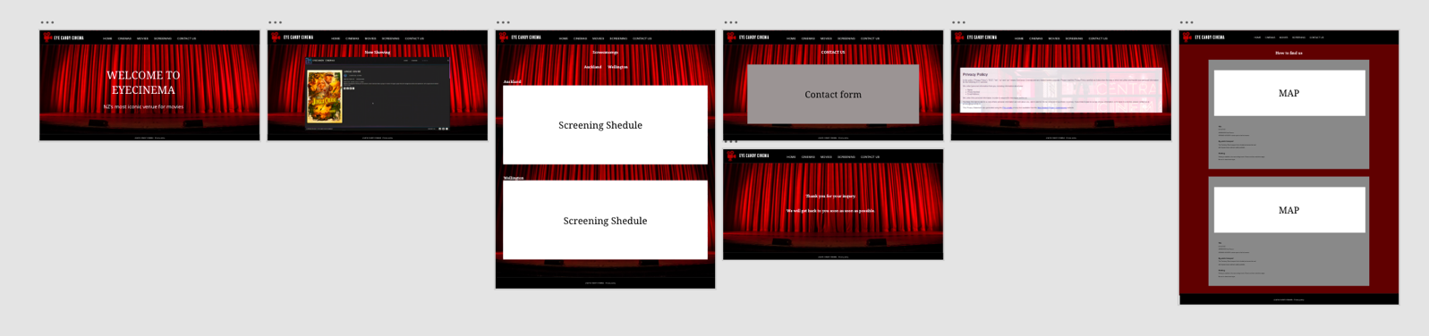

1. **A brief test plan indicating how you intend to conduct your testing and what browser(s) you will use for testing your site.**Test browser: Google Chrome  
     
   Test plan :  
   - Checking all links (external and internal link). If it is working or not.  
   - Checking any spelling mistake  
   - Checking images if there is any broken images or not  
   - Using developer tool to check if there is any error messages